W58D无油空气压缩机
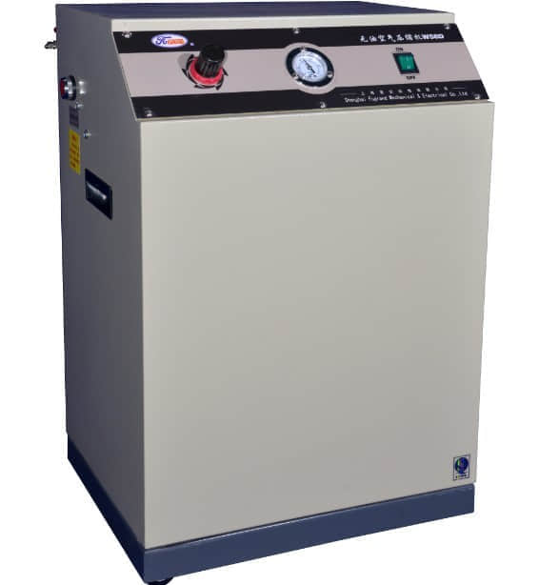
技术参数
电 源: ........................ 220V
额定功率: ..................... 560W
排气量: .................... 58L/min
最高排气压力: ............... 0.8MPa
储气罐容量: .................... 23L
重 量: ........................ 30KG
噪 音: ........................ 45dB
SPECIFICATIONS
Powersupply: .................. 220V
Power: ........................ 560W
Discharge: ................. 58L/min
Max.Workpressure: ........... 0.8MPa
Tank capacity: ................. 23L
Weight: ....................... 30KG
Noise level: .................. 45dB

